Andaman Local Goat
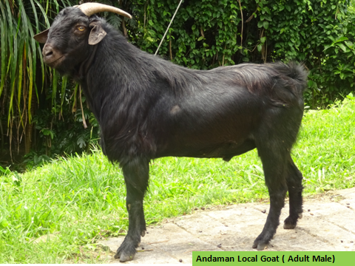

Jai Sunder, A. Kundu, M.S.Kundu & T. Sujatha
All India Coordinated Research Project on Goat Improvement

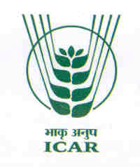
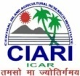
ICAR-Central Islands Aagricultural Research Institue, Port Blair, A & N Islands
E-mail : jaisunder@rediffmail.com

Goat farming is an integral enterprise in agriculture and an important activity for accelerating the rural livelihood and nutritional security. Andaman local goats resemble Black Bengal and were brought from Bengal and adjacent areas in different phases of inhabitation and rehabilitation of migrated/settled people. These goats are well adapted to the island condition and are widely distributed throughout Andaman Islands. These goats are locally called as Andaman Local Goat. These goats resemble Black Bengal and were brought from West Bengal and adjacent areas in different phases of inhabitation and rehabilitation of migrated/settled people. They are locally called as Andaman Local Goat and three colours are available, Black, Brown and White. They are short to medium sized leg with compact body. Kidding pattern in these does prolific, twins and triplets.
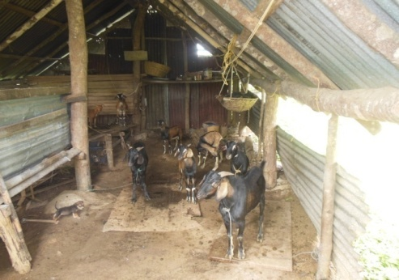
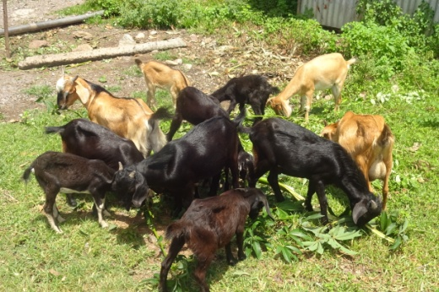
Baseline information:
It was observed in the base line survey that there is no appreciable trait or physical character in the Andaman local goat. There was not organized / scientific goat farming except few farmers. Eighty per cent of the farmers had constructed kutcha shelter either of mud floor or slightly elevated type for the goats. Rest of the farmers were practicing only free range system without any housing system. Feeding practices were only wheat. No balanced concentrate supplemental feeding, no supplementation of mineral mixture, over feeding during festival season and only grazing / feeding leaves. There was no regular deworming, farmers are not coming forward for treatment and vaccination is being done for only FMD. Female goats were retained and only male bucks are being sold only during festival seasons. Bucks are sold at the rate of Rs. 4000 to 5000 per animal. Middle men realise more money rather than goat keepers. There is no cooperative society for goats. Common field problems such as pre-mature breeding, dystocia, bloat, pneumonia, tetanus and parasitic infestation are more frequent in the farmers’ field of the present project area. Majority of goat keepers in the project area had only school level education. Average family size was 5-6. Flock size was ranging from 5 to 20.
Population & Flock statistics: Majority of the population of goat in Andaman & Nicobar Islands is belongs to Andaman local goat type. Total goat population in the island is approximately 65324 which are 42.2 % of the total livestock population. The average flock size of the Andaman local goat is approximately Average family size was 5-6. Flock size was ranging from 5 to 20.
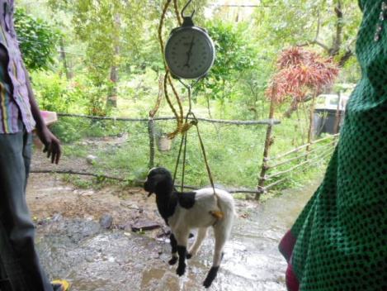
Body weight: The average mean body weight (kg) at birth, 3, 6, 9 and 12 months of ages of female goats was 1.730 ± 1.23, 5.042 ± 0.37, 8.281 ±0.57, 11.938 ± 0.97 and 15.670 ± 0.73 and the respective weights of male goats was 1.910 ±0.15, 5.125 ± 0.28, 10.367 ± 0.73, 13.273 ± 0.76 and 16.450 ± 0.72. In general single born kids were heavier than the multiple born kids.
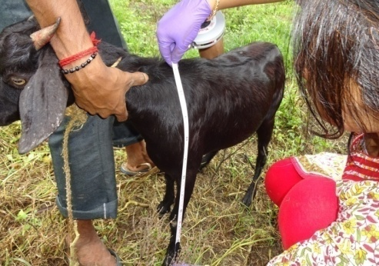
Biometric dimensions: The overall chest girth (CG) for male goat at birth, 3, 6, 9 and 12 months was 25.9±2.18, 37.45±1. 53, 47.25±3.51, 53.07±2.10, 60.12±1.89 respectively. Measurements for paunch girth (PG) at birth, 3, 6, 9 and 12 months were 26.19±3.02, 40.43±2.42, 53.42±5.01, 58.53±3.31, 64±2.62 respectively. Measurements for body length (BL) at birth, 3, 6, 9 and 12 months were 25.04±3.56, 36.02±1.45, 42.92±3.64, 46.76±2.67 and 49.25±2.25 respectively. Measurements for height at withers (HW) at birth, 3, 6, 9 and 12 months were 26.19±1.68, 36.07±2.91, 43.84±2.73, 49.35±1.47 and 53±1.56 respectively. The overall chest girth (CG) for Female goat at birth, 3, 6, 9 and 12 months was 24.4±0.38, 37.38±0.54, 46.4±0.82, 52.05±1.02, 60.21±0.76 respectively. Measurements for paunch girth (PG) at birth, 3, 6, 9 and 12 months were 25.08±0.41, 37.76±0.86, 46.7±1.10, 56.0±1.30, 67.0±1.34 respectively. Measurements for body length (BL) at birth, 3, 6, 9 and 12 months were 24.60±1.0, 34.38±0.49, 41.53±0.85, 43±0.91 and 50±0.86 respectively. Measurements for height at withers (HW) at birth, 3, 6, 9 and 12 months were 25.3±0.38, 34.3±0.75, 40.1±0.65, 44.9±0.71 and 51.93±0.63 respectively.
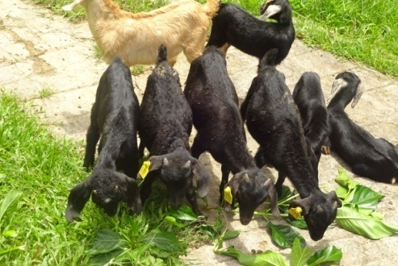
Reproduction performance : Age at first mating, weight at first mating, age at first kidding, weight at first kidding, service period, kidding interval and gestation period was 260 ±15.0 days, 8.49±0.89 kg, 420.0 ±12.0 days, 13.26±1.61kg, 101.20±11.23 days, 300.0 ± 20.0 days and 147.0± 2.0 days respectively . The kidding percentage of 142.25 per cent on the basis of does kidded and the kidding rate of 1.61 was recorded in the present stock of Andaman local goats.
Diseases: Common field problems such as pre-mature breeding, dystocia, bloat, pneumonia, tetanus and parasitic infestation are more frequent in the farmers’ field of the present project area.
Diseases | Symptom | Treatment and care
Foot rot | Lameness/limping, smell from affected foot | Foot bath with copper sulphate, chlorine, 10 % formaline. Regularly trim hoof
Internal parasite | Loss of weight, starved appearance, less milk production, ruffled hair and coat, diarrhoea is often present, anaemia | Regular deworming
External parasites | Goats will scratch a lot, general restlessness, loss of weight, frequent loss of hair, decreased milk production. | Apply neem oil, dipping, and regular deworming.
Udder infection  (mastitis) | Udder is swollen, lumpy and painful, dissimilarity of both quarters, loss of milk production., milk is salty in taste, milk with cheesy flakes / clots, colour of milk reddish, brown or yellow with pus | Keep the udder clean and dry, and milk the goat in a clean and dry place, milker should trim his nails, hands washed before milking and should be free from infectious diseases, Keep flies away, especially during milking, form goats.
Poisoning | Appears suddenly in most of the cases, excited or unsteady movement of the goat. Goat may become dull and unconscious, Convulsions and eventual death may ensue, Severe pain, vomiting and fluid faeces. | Drench the goats with salty water to make them thirsty, Chalk powder mixed with burnt bread or catachue can be administered to slow-down the absorption of poison from the stomach.
Bloat | Stomach is swollen greatly, goat does not eat grass and appears restless, difficult breathing; death may ensue in absence of proper treatment. | Force the goat to drink 100 ml of groundnut oil, liquid paraffin. Do not allow goat to eat too much of fresh leguminous grasses, Provide high fiber diet (straw or hay) before allowing onto new grazing land, in severe eases.

